High Hopes Therapeutic Riding, Inc.
Strategic Plan 2015-2019

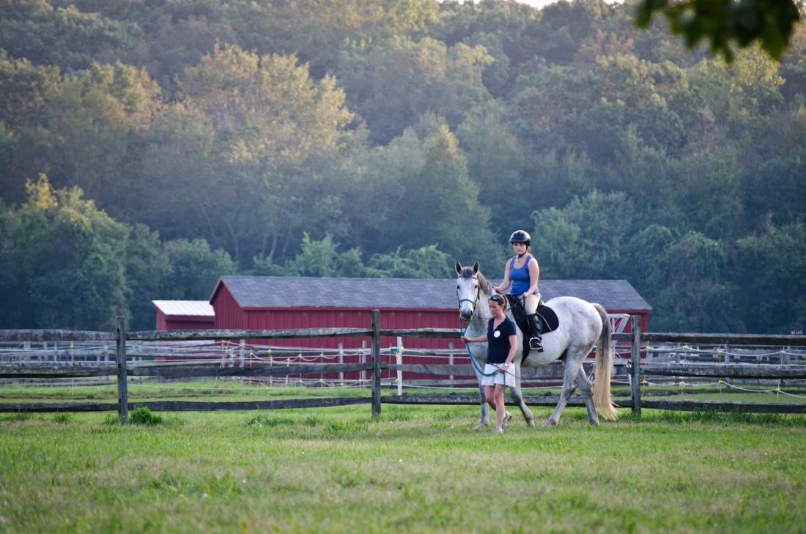

Contents

High Hopes Mission & Values - - - - - - - - - - - - - - - - - - - - - - - page 3

Key Statistics - - - - - - - - - - - - - - - - - - - - - - - - - - - - - - - - - - - - page 4

Organizational Background - - - - - - - - - - - - - - - - - - - - - - - - - page 5

Strategic Planning Vision - - - - - - - - - - - - - - - - - - - - - - - - - - - page 6

Strategic Planning Process - - - - - - - - - - - - - - - - - - - - - - - - - - page 7

Strategic Goals and Action Steps - - - - - - - - - - - - - - - - - - - - - page 8

Mission

The mission of High Hopes is to improve the lives of people with disabilities through the benefits of therapeutic horseback riding, equine assisted activities and therapies, and training and education while being a proactive leader, mentor and advocate for our profession.

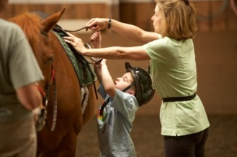

Values

Quality
We are committed to the highest level of quality throughout our programs, in our care for horses and in our interaction with participants, volunteers, donors and other members of the community.

Teamwork
High Hopes’ certified instructors, qualified staff and committed volunteers work together to create an inclusive environment providing the optimal experience for participants.

Education
High Hopes promotes education within the field of Equine Assisted Activities and Therapy (EAAT) and values learning in collaboration with our participants and community.

Leadership & Innovation
High Hopes develops leaders who are committed to excellence, current with advances in EAAT, and eager to share innovative solutions that will enhance the experience for participants today and in the future.

Serving the Community
High Hopes strives to effectively serve its community and to be an active and valued community participant.

Key Statistics

• Contributed income funds 78% percent of every High Hopes participant’s lesson.
• Request for financial assistance has increased an average of 7% over the last 5 years.
• 1,775 people were served in 2013 – 2014.
• More than 675 volunteers donated over 31,000 hours of their time in
2013 – 2014.
• 27 specially trained horses work in our program.
• 240 participants are served each week.

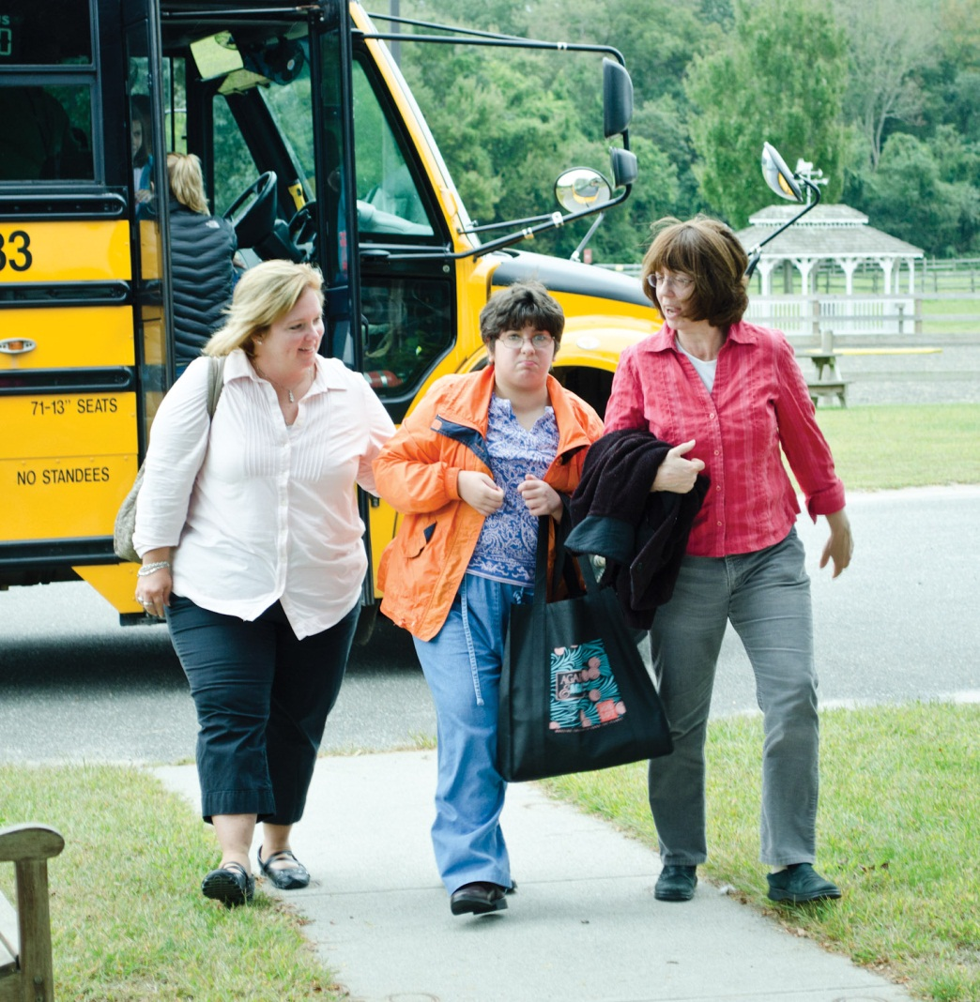

Organizational Background

History: Founded in 1974 by Sis Gould and a dedicated group of volunteers who traveled from barn to barn throughout the region, High Hopes has grown into a 120 acre facility serving 1,775 people annually with the help of more than 675 volunteers and our herd of 27 specially trained therapy horses. Since 1979, High Hopes has been accredited by the Professional Association of Therapeutic Horsemanship International (PATH Intl.), the organization that sets the standards for the therapeutic riding profession, and we have maintained Premier Accreditation status since it was first instituted by PATH Intl. in 1992.

What we do: High Hopes provides a challenging yet secure environment in which to experience not only physical and occupational therapy but also freedom, mobility and accomplishment. Our programs are carefully designed to foster independence and self-confidence, to teach life skills and provide challenging individualized therapeutic, recreational and educational activities to a population whose resources are too often limited. The High Hopes experience combines the healing power of the human-animal bond with targeted and attainable goals and we offer our programs to all who might benefit from them, regardless of financial means.

Who we serve: Our participants come to us from special education classes at local schools, as referrals from physicians, social service agencies, group homes, rehabilitation centers and through individual referrals by other participants. The challenges faced by our participants include autism, cerebral palsy, Down syndrome, muscular dystrophy, visual and hearing impairments, emotional and social behavior disorders, and traumatic brain and spinal cord injuries.

During the summer, in addition to our regular programs, High Hopes offers a series of weeklong sessions of inclusive summer camps where children with and without disabilities participate together as well as a specialized immersion program for children with autism spectrum disorders conducted in collaboration with therapists from Lawrence & Memorial Hospital in New London, Connecticut. We serve our community through school in-service programs, field trips and experiential learning opportunities provided both on-site and by visits to schools, senior centers and other local community groups. We are also dedicated to providing advocacy for people with disabilities, family education and support and training for therapeutic riding instructors from all over the world.

Participants range in age from 3 to 77 years; 56% are age 13 or younger. They come from 65 towns throughout Connecticut. High Hopes serves the school districts of New London, Haddam-Killingworth, East Lyme, Lyme/Old Lyme, Essex and Deep River. These groups represent 25% of all participants. High Hopes works with many of the group homes and day programs in our community including Boys & Girls Village, VISTA, Brian House, Inc., SARAH, Inc., Connecticut Juvenile Training Center, Clinton Harbor, Rushford Academy, LEARN, Connecticut Valley Hospital and The Albert J. Solnit Center.

Strategic Plan Vision

The Strategic Plan Vision is to provide programs that serve more people in a variety of innovative ways, to meet the needs of diverse populations and to broaden our geographical reach within a sustainable model.

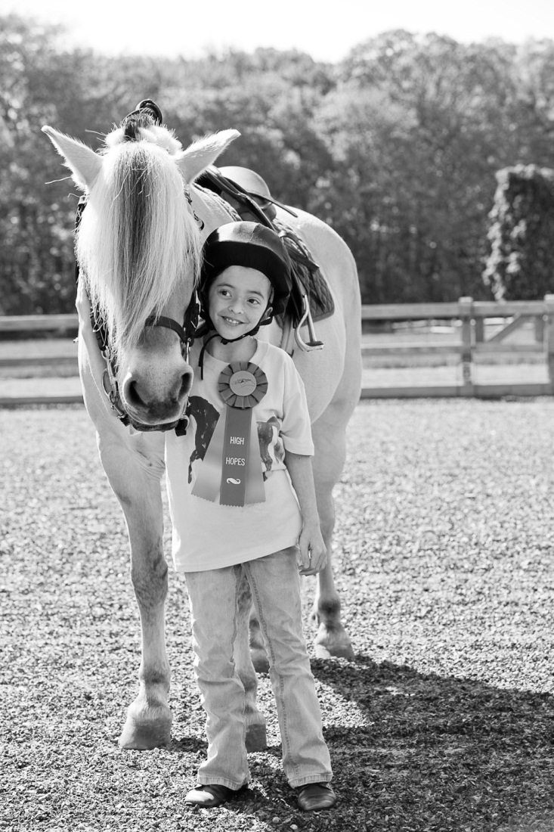

The Strategic Planning Process

The initial goal of the Strategic Planning Committee was to formulate key strategic issues. The last strategic planning initiative was focused on operational excellence. This time the Strategic Planning Committee felt the organization was in a much stronger position, making it possible to ask new questions, take new risks and respond to new opportunities. In the discovery phase of the Strategic Planning process, five strategic opportunities and challenges emerged:

Develop Satellite Operations Model
Over the course of the Strategic Planning Process two pilot programs for satellite operations were conducted by High Hopes. The first took place at Camp Harkness in Waterford, CT. The initial pilot program worked with the residential camp program and has expanded to include community-based programs as well. High Hopes at Camp Harkness allows us to expand our geographic reach as participants come from throughout the state. The second opportunity for development is at Lord Creek Farm in Lyme, Connecticut. The pilot program at this site will focus on participants with mental health issues (i.e. veterans, disadvantaged youth, and families in crisis) who will benefit from a peaceful, less structured environment than presented at our Town Woods facility. Both of these satellite operations allow High Hopes to create new collaborations with other Connecticut human service and educational organizations.

Expand Program Initiatives
Over the past five years High Hopes has seen an increased demand, through our relationship with area school districts, for equine facilitated psychotherapy and equine facilitated learning. We look to develop these programs to include vocational training and other forms of alternative education services.

Increase Training and Education offerings
As the therapeutic riding profession and demand for equine assisted therapeutic activities grows, High Hopes has seen a corresponding growth in our training and education programs. With the hiring of a full time Training and Education Director we are looking to explore opportunities in distance education, professional development workshops, consultant services and partnerships with other programs to train and mentor instructor candidates.

Build a Sustainable Income/Capital Model and Explore Alternative Funding Sources
Participant fees cover only 22% of High Hopes’ total operational expenses. Despite having an active and successful fundraising program financial projections over the next five years show expenses exceeding projected revenue. To prevent this, High Hopes needs to improve its existing revenue sources, accurately communicate the value proposition for our services and examine productivity outcomes and their impact. An analysis of the feasibility for conducting a capital and/or endowment campaign will also be explored.

Strategic Goals and Action Steps

To take advantage of these strategic opportunities and challenges the Strategic Planning Committee has outlined the following goals and related action steps:

Program Goals

High Hopes will maintain a strong leadership role within the field of Equine Assisted Activities and Therapies (EAAT) through the continued evolution and innovation of program services, providing high quality, individualized programming.

High Hopes will expand training and education activities that are impactful to the field on a local, national and international level.

Program Action Steps

Examine current program services and design new offerings which will optimize existing resources while providing participants with enhanced experiences.

Pilot satellite activities and, if found feasible, incorporate into High Hopes’ long term plan.

Expand training and education activities to include distance education and the development of High Hopes branded courses, thereby providing a reliable revenue stream in support of High Hopes operations.
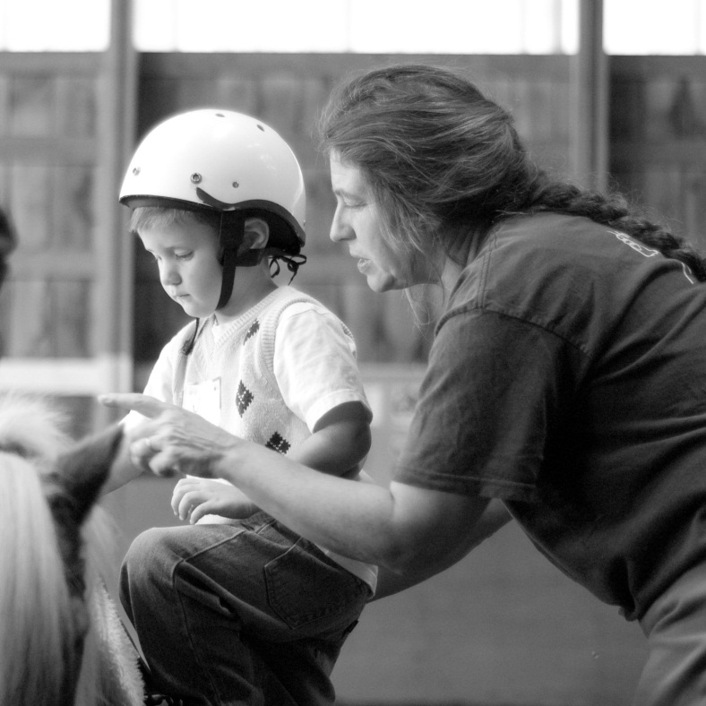

Infrastructure

High Hopes will ensure that human and equine resources are positioned to support its programs into the future.

High Hopes will ensure that its facility, land use and technology needs are positioned to support its programs into the future.

Infrastructure Action Step

Conduct organizational inquiries and capacity analysis to identify constraints in all areas and respond by developing and implementing an optimal resource model.

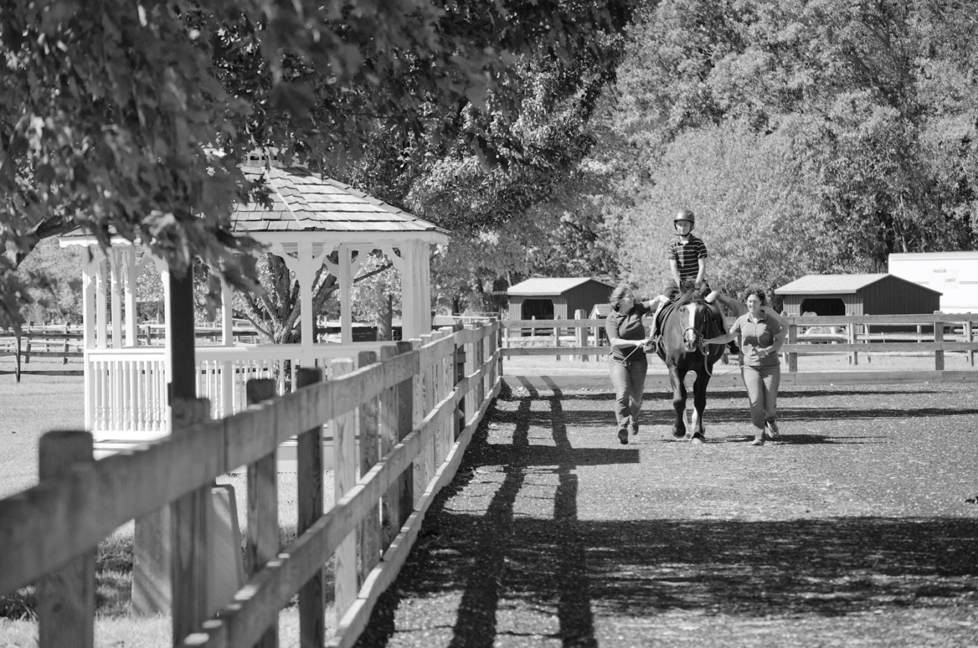

Finance Goal

High Hopes will create a robust financial model which will support program growth and innovation into the future.

Finance Action Steps

Analyze present and future projected expenses to identify and implement ways to increase efficiency and increase potential savings.

Develop recommendations to address funding gaps including optimization of the fee structure and scholarship policies, expanded fund development efforts and identification of new revenue generating activities.

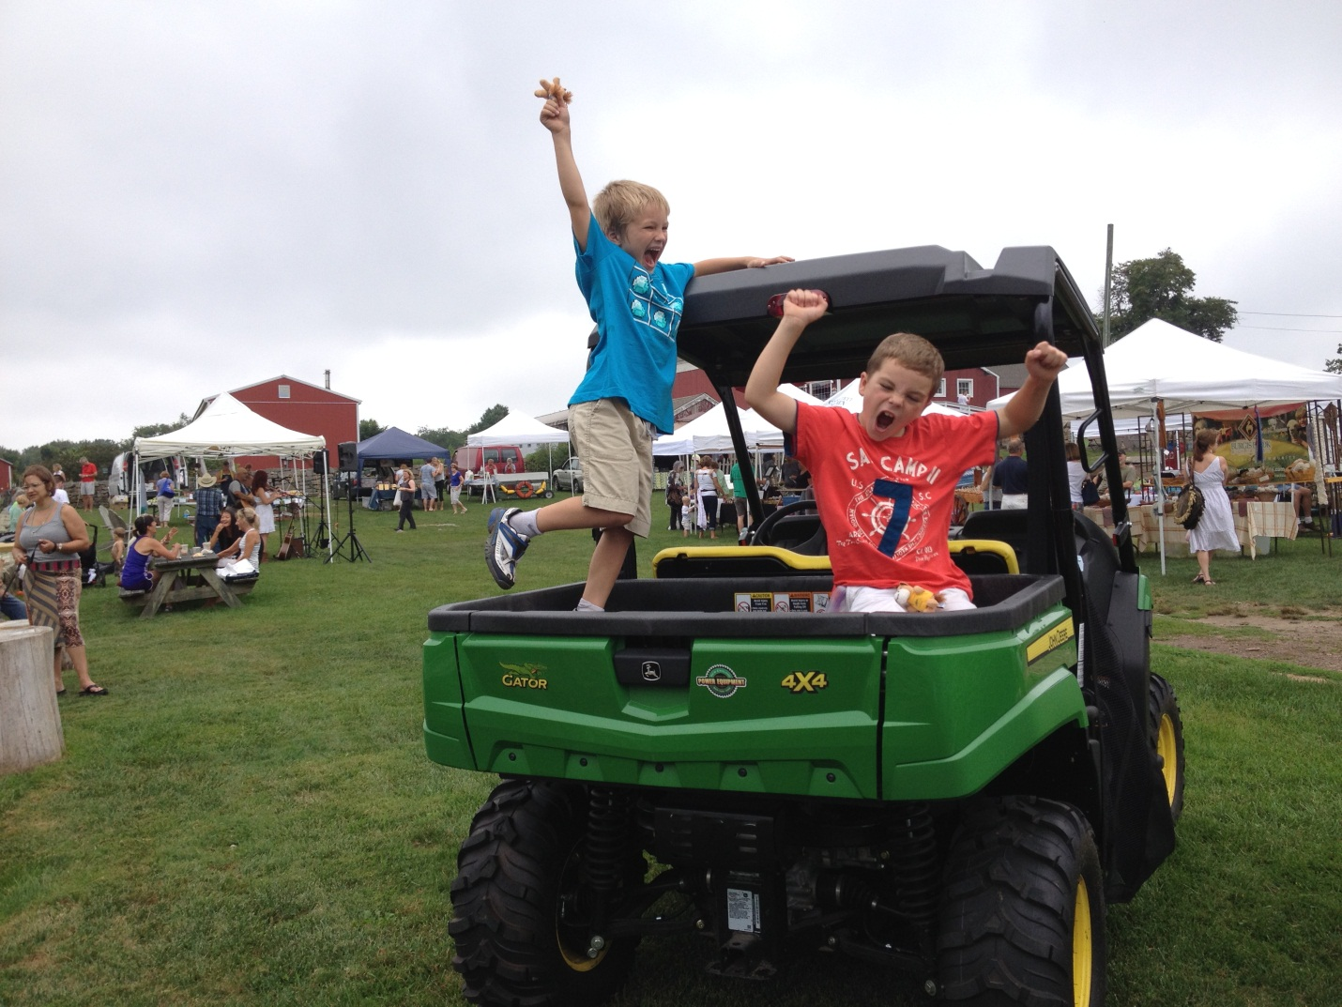

Governance Goal

High Hopes will ensure that a governance structure is in place which supports a strong and diversified board capable of providing the leadership needed to fulfill the mission.

Governance Action Steps

Examine current structure, policies and practices of the Board and committees to ensure that the composition and activities of the Board are aligned with the needs of the organization.

Increase engagement of staff and trustees in fund development activities through ongoing education, preparation and training.

Increase diversity on committees and the Board to increase community involvement and to support a culture of innovation and philanthropy.

